Pokhara University

Level: Bachelor | Semester – Fall | Year : 2009
Programme: Architecture |  | Full Marks : 100
Course: Statics & Dynamics |  | Time : 3hrs.

Candidates are required to give their answers in their own words as far as practicable.
The figures in the margin indicate full marks.

Attempt all the questions.

1. | - Determine the resultant of three forces as shown. | 7

20⁰
75⁰
700 N
800 N
600 N

 | - The 60 N force P is applied at point C of the bent bar. If θ = 45°, determine the moment of P about point A. For what value of the angle θ will the moment about point A be maximum? Determine this maximum value (M_{A}) _{max.}  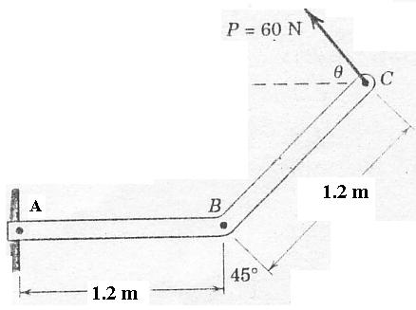 | 8
2. | - Knowing that θ = 40°, determine the smallest force P for which equilibrium of the 7.5 kg block is maintained 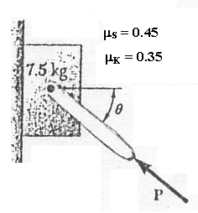  - Determine moment of inertia about centroidal axis of given figure. 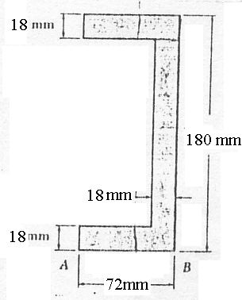 | 8  7
3. | - A ski jumper starts take off velocity of 100 m/s with 30⁰ to horizontal and lands on a straight landing hill inclined at 15⁰. Determine time between take off and landing, the length d of the jump.  15⁰  100m/s  d  - A bus starts from rest on a curve of 300 m radius and acceleration at constant rate a_{t} =0.75 m/s².Determine distance and time the bus will travel before the magnitude of its total acceleration 0.9 m/s². | 8  7
4. | A single wire ACB passes through a ring at C attached to a sphere which revolves at a constant speed v in the horizontal circle shown. Knowing that the tension is the same in both portions of the wire, determine the speed v. 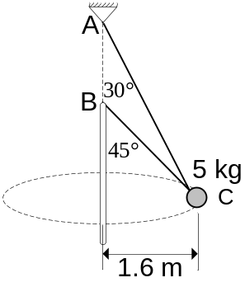 | 15
5. | Neglect friction of the 500 g collar against its vertical guide and compute the velocity of the collar after it has fallen 7 m. starting from rest in the position shown in figure. The unstretched length of spring is 2 m. 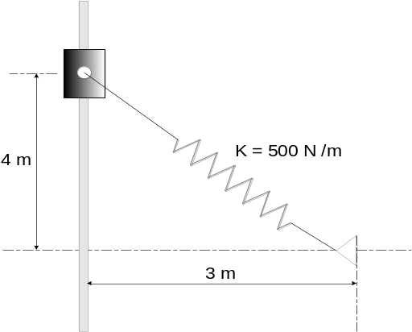 | 15
6. | A pulley weighting 38 kg and having a radius of gyration of 27 cm is connected to two blocks as shown. Assuming no friction, determine angular acceleration of pulley and acceleration of block.  A  8 kg  B  6 kg  50cm  70cm | 15

.

7. | Write short notes on (Any Two)  a. Particles and rigid body  b. Kinetic Energy  c. FrictionS | 5×2

